
Lesson 11: Wave After Wave
Scratch
VIDEO GAME CREATION
This week: clearing a wave of enemies no longer means the game is over - it means the NEXT wave begins. Clear all 3, and that's when you really win.
Open your own [YourName]Game project from Lesson 10 - don't start a new one.
Tip: no new assets this week - waves reuse the spawn routine you already built in Lesson 10. This completes the Level 2 Complete milestone!

Setup
- Open your [YourName]Game project from Lesson 10.
- Create two new variables, wave and total_waves (both "for all sprites"). Tick the checkbox next to wave so it shows on the stage during play.

Level 1 - Minimal (MVP)
Clearing a wave's enemies spawns a fresh wave, up to 3 total. Clearing wave 3 triggers the real win. The current wave number is shown on screen.
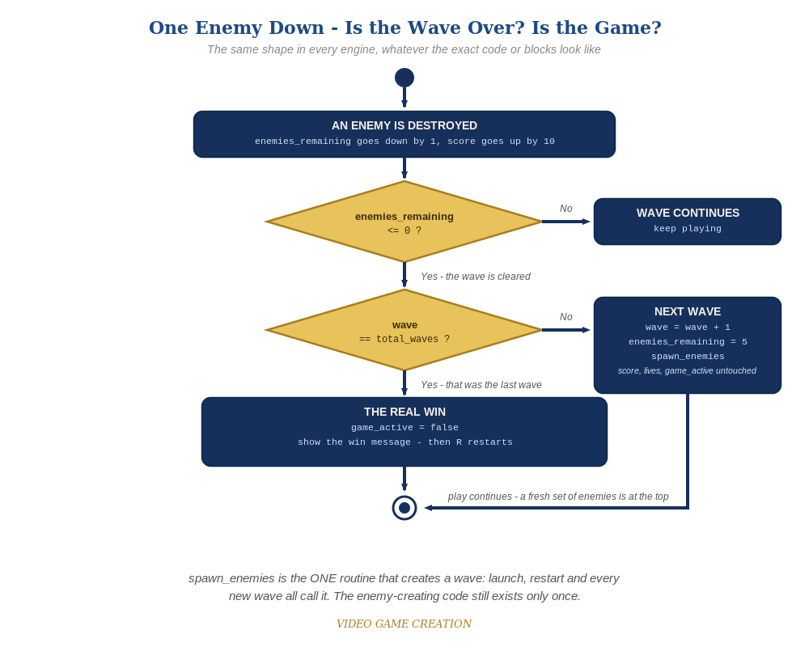
Clearing a wave asks a second question. If it was not the last wave, the game spawns a fresh set of enemies and carries on. The same shape in every engine.
- On GameManager, find your "when I receive [start game]" script. After "set lives to 3", add "set wave to 1" and "set total_waves to 3". Add "broadcast [spawn enemies]" as the very last block, after "set game_active to true". GameManager now ASKS for enemies instead of the Enemy sprite making them on its own.
- On the Enemy sprite, find your spawn script (the one holding repeat 5: create clone of myself). Change its hat block from "when I receive [start game]" to "when I receive [spawn enemies]". Leave the separate "when I receive [start game]" / "delete this clone" script exactly as it is, so a restart still clears the old clones.
- On GameManager's "when I receive [enemy hit]" script, revise the win check (code below): inside "if enemies_remaining = 0 then", add an if/else. If wave = total_waves, win as before. Otherwise, change wave by 1, set enemies_remaining to 5 and broadcast [spawn enemies] again.
- Click the stage and play through. Clearing wave 1 or 2 should bring a fresh set of five instead of ending the game, and the wave number on stage should go up. Clearing wave 3 should show "You Win!".
- Keep your sounds: if you added the win, life-lost or game-over sounds in Lessons 6 and 8 (Level 3), they stay. The code below shows them as plain lines, in the scripts where you put them. If you skipped that goal, ignore those lines.
Highlighted lines are new this week; everything else is code you already have.
// GameManager (hidden sprite):
when I receive [start game]
set score to 0
set lives to 3
set wave to 1
set total_waves to 3
set enemies_remaining to 5
set game_active to true
broadcast [spawn enemies]
when I receive [enemy hit]
change enemies_remaining by -1
change score by 10
if enemies_remaining = 0 then
if wave = total_waves then
set game_active to false
broadcast [you win]
else
change wave by 1
set enemies_remaining to 5
broadcast [spawn enemies]
// Enemy sprite (only the hat block changes):
when I receive [spawn enemies]
repeat 5
create clone of myself
// (your existing position and wait blocks stay here)
// Enemy sprite (unchanged - still clears old clones on a restart):
when I receive [start game]
delete this clone

Before You Test: Check Your Game State
Remember Lesson 10: a restart must put ALL game state back. This week you added new state, so check it too:
- wave and total_waves: confirm "when I receive [start game]" sets wave back to 1 (and total_waves to 3), so a restart always begins at wave 1.
- Anything extra you added for waves (a message, an effect, a sound): make sure "when I receive [start game]" puts it back too.

Level 2 - Complete (Alpha/Beta)
Wave transitions are seamless and correct every time - no double-spawns, no skipped waves, exactly 3 waves before the real win, and restarting always returns to wave 1. Nothing in the code needs to change for Level 2; it is about testing what you built.
- Play a full 3-wave game: confirm waves 1 and 2 each spawn a fresh set of five with no win message, and only wave 3 triggers "You Win!".
- Let all 3 lives run out partway through wave 2 and confirm "Game Over" still appears, not a wave transition.
- Press R after a win or a loss and confirm wave is back to 1, along with score and lives, with exactly five enemies on screen.

Level 3 - Refined (Ready to Publish) - pick any that interest you
- The Stalemate is back - and now it can freeze the game at any of the three waves. If you fixed it in Lesson 10, check that your fix still works with waves. If you didn't, this may be the week it gets annoying enough to deal with. Find the cause and fix it in the way you, the Designer, think best. (Test it: let some enemies escape, destroy the rest, in wave 1, wave 2 and wave 3.)
- Visual: briefly announce each new wave, for example "say [Wave 2!] for 1 seconds" on the Player sprite when it hears [spawn enemies] for a wave 2 or later.
- Structure: notice [spawn enemies] is now broadcast from two places (the end of "start game" and the else branch of the win check), but the enemy-creating blocks exist only once.

If Something's Wrong
- Wave 1 immediately shows "You Win!": the if/else must compare wave = total_waves. Without that check, any cleared wave looks like a full win.
- New waves never spawn: confirm "broadcast [spawn enemies]" is inside the else branch, and that the Enemy sprite's spawn script starts with "when I receive [spawn enemies]" (spelled exactly the same as the broadcast).
- Ten enemies instead of five: the Enemy sprite still has a spawn script on "when I receive [start game]" as well as the new one. Only the "delete this clone" script belongs on [start game].
- Score or lives jump between waves: the else branch should only change wave and enemies_remaining, nothing else.
- A wave never ends after you let some enemies escape - no next wave, no win, no Game Over: that is the Stalemate from Lesson 10 (Level 3), not a typo in your code. Escaped enemies cost a life but never count toward clearing the wave.

Want More?
Student Resource List > Scratch section, or scratch.mit.edu/ideas

